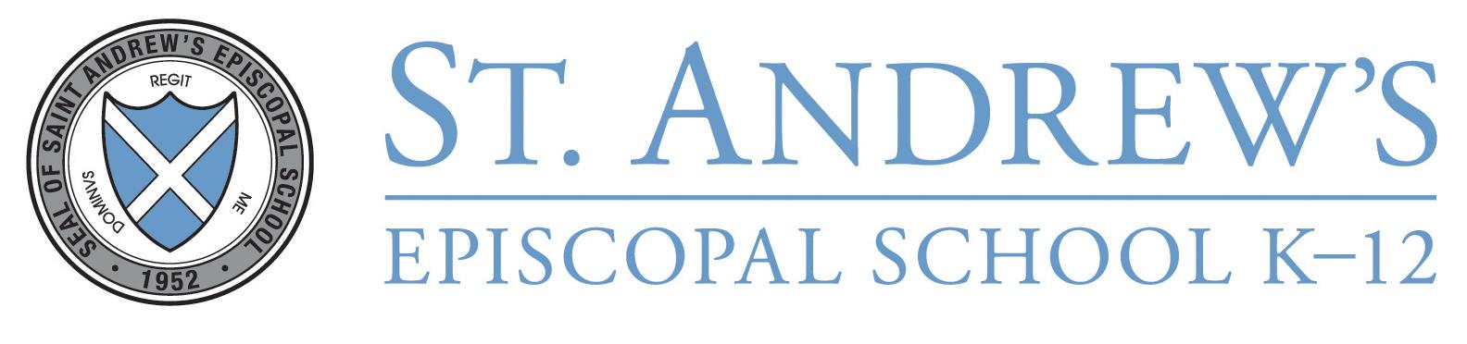
Assistant Head of Middle School for Student Life

St. Andrew's Episcopal School in Austin, TX seeks to hire an Assistant Head of Middle School for Student Life for the 2026-2027 school year. This position works closely with the Head of Middle School and Assistant Head of Middle School for Academics to shape and maintain the character and culture of the division. We are looking for candidates who, above all, genuinely love working with middle school students and understand their developmental needs. Strong candidates will possess flexibility, a calm and level-headed demeanor, and a sense of humor.
The primary responsibility of this role is to ensure the well-being of all 235 middle school students across all four pillars of our school. A holistic approach is central to the student experience at St. Andrew’s, as we believe raising well-rounded people is our most important responsibility. The next Assistant Head for Student Life will need to effectively navigate the delicate balance of developing authentic relationships while also upholding our community standards of behavior. This position spearheads our discipline system, which is rooted in a restorative justice approach. Excellent communication skills with both parents and teachers alike are essential, as it takes a village to help students navigate adolescence.
There are several other components to this role:
- Lead our robust Middle School leadership program, which includes our House System as well as other student leadership organizations
- Serve as a 6th grade advisor
- Teach an enrichment course each semester
- Regular attendance at after school events and extracurricular activities
- Serve on the Middle School Admissions Committee
- Collaborate with Lower and Upper School counterparts to ensure a seamless transition for students between divisions
- Serve on the Student Support Team
- Consistent presence during middle school chapel, break time, lunch, and dismissal
- Coordinate annual handbook reviews related to policies & procedures
- Attend all grade level class trips
- Oversee attendance & planned absence protocols
- Plan & lead Community Time every Tuesday morning
- Other duties as assigned by the Head of the Middle School
Preferred candidates must hold a minimum of a bachelor's degree and have experience working in middle school.
OUR SCHOOL
St. Andrew’s is a co-educational Episcopal K-12 day school, enrolling approximately 990 students on two campuses in Austin, Texas. The school strives to help young people from diverse racial, religious, ethnic, and socioeconomic backgrounds to achieve their potential not only in intellectual understanding but also in aesthetic sensitivity, physical well-being, and moral decisiveness so that they may lead productive, responsible lives, not only for themselves but also for their community. For more information about St. Andrew’s School in Austin, please access our website: www.sasaustin.org.
OUR MISSION
St. Andrew's develops exemplary scholars, artists, athletes and servants in a loving Episcopal community who are curious, courageous and compassionate global citizens.
TO APPLY
Please submit your resume and letter of interest to Kathleen Quisenberry, Human Resources Manager, at hr@sasaustin.org. Candidates who contribute to the cultural and ethnic diversity of the community are encouraged to apply.
St. Andrew's is committed to providing equal opportunity in all personnel actions and in the administration of all policies and programs.
St. Andrew's employs individuals without regard to race, color, nationality, ethnicity, religion, disability, sex, gender identity or sexual orientation as protected by federal, state, or local law.

