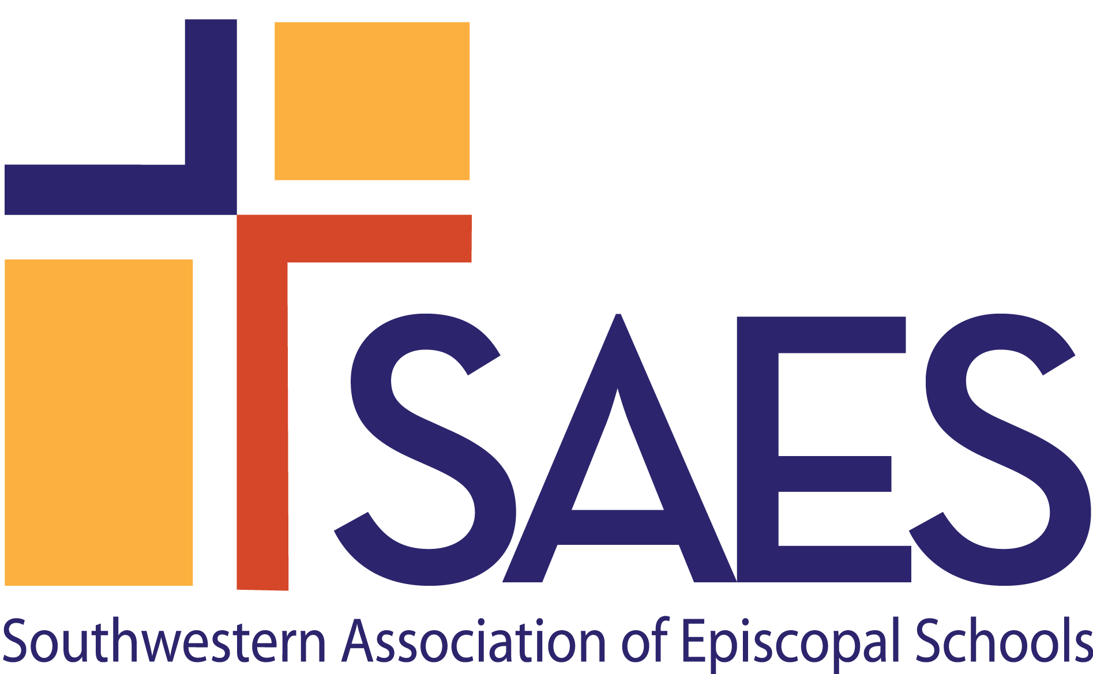

***Documents in Adherence to Standards for Applicant Schools 2025***

The *Documents in Adherence to Standards*, are evidence of the school’s compliance with SAES *Standards* and of the school’s demonstration that it is employing best practices in its policies and operations. Submission of the DAS for Applicant Schools after a school has hosted a Preliminary Visit by a member of SAES Staff and a member of the Standards Committee will qualify a school to be considered for preliminary accreditation. The complete DAS will be required at the time of the On-Site Visit.

|  |  |  |
| --- | --- | --- |
| **MISSION** | | x |
| 1 | The published mission of the School |  |
| **EPISCOPAL IDENTITY** | |  |
| 1 | School/church shared use agreement (if applicable), together with description of how costs are allocated between church and school |  |
| 2 | Evidence that anyone working with students on a regular basis has been certified/re-certified in Safe Church,  Safe Communities as directed by the diocese |  |
| **GOVERNANCE** | |  |
| 1 | Evidence of the school’s bylaws, articles of incorporation/Certificate of Formation, and charter (if applicable) |  |
| 2 | If the school is separately incorporated, evidence of 501(c)(3) status. If the school is not separately incorporated, provide evidence that the school is by charter affiliated with a legally constituted not-for-profit church. |  |
| 3 | Required School Policies   * Employee Whistleblower * Trustee Conflict of Interest * Grievance/conflict resolution for employees, students, parents, trustees * Confidentiality agreement that trustees sign annually * Anti-bullying/anti-hazing for students * Anti-harassment that includes sexual misconduct/sexual assault for students and employees * Location and accessibility of essential records in the event of the permanent closure of the school |  |
| **ORGANIZATION & ADMINISTRATION** | |  |
| 1 | Published statement regarding the school’s non-discrimination policy and demonstration of compliance with IRS Revenue Procedure 75-50 |  |
| 2 | Employee Handbook |  |
| 3 | Parent-Student Handbook |  |
| **TEACHING & LEARNING** | |  |
| 1 | Curriculum scope and sequence, standards, and/or mapping |  |
| 2 | Program materials prepared for parent and public information |  |
| 3 | Discipline policies/student Code of Conduct |  |
| 4 | Evidence of parent communication regarding student progress and performance (e.g. report cards, progress reports) |  |
| **FISCAL RESPONSIBILITY** | |  |
| 1 | For the most recently completed fiscal year, audited financial statement with management letter or financial review with management letter. |  |
| 2 | Current budget, actuals year-to-date with prior two years year-end budget and actuals |  |
| 3 | Verification and summary schedule of school’s insurance coverages |  |
| 4 | Last three years tuition and fee schedules |  |
| **FACILITIES, SAFETY & SECURITY** | |  |
| 1 | Daycare and program licenses, if applicable |  |
| 2 | Crisis/emergency response plans |  |
| 3 | Current safety inspections and certificates showing that the school meets all applicable fire, safety, and health requirements of diocesan, local, state, and federal authorities. |  |
| 3 | Evidence that the school has a process for conducting initial background checks and for re-checking as required by state licensing (if applicable) and diocese. Checks have been made on all employees and frequent volunteers, including third party providers and others working in programs that operate outside of the school day/year (such as before and extended day care, weekend and summer programs. |  |
| **HEALTH & WELL-BEING** | |  |
| 1 | Protocol for handling communicable and non-communicable diseases, including immunizations/immunization exemptions (if applicable). Do not submit individual health or immunization records. |  |