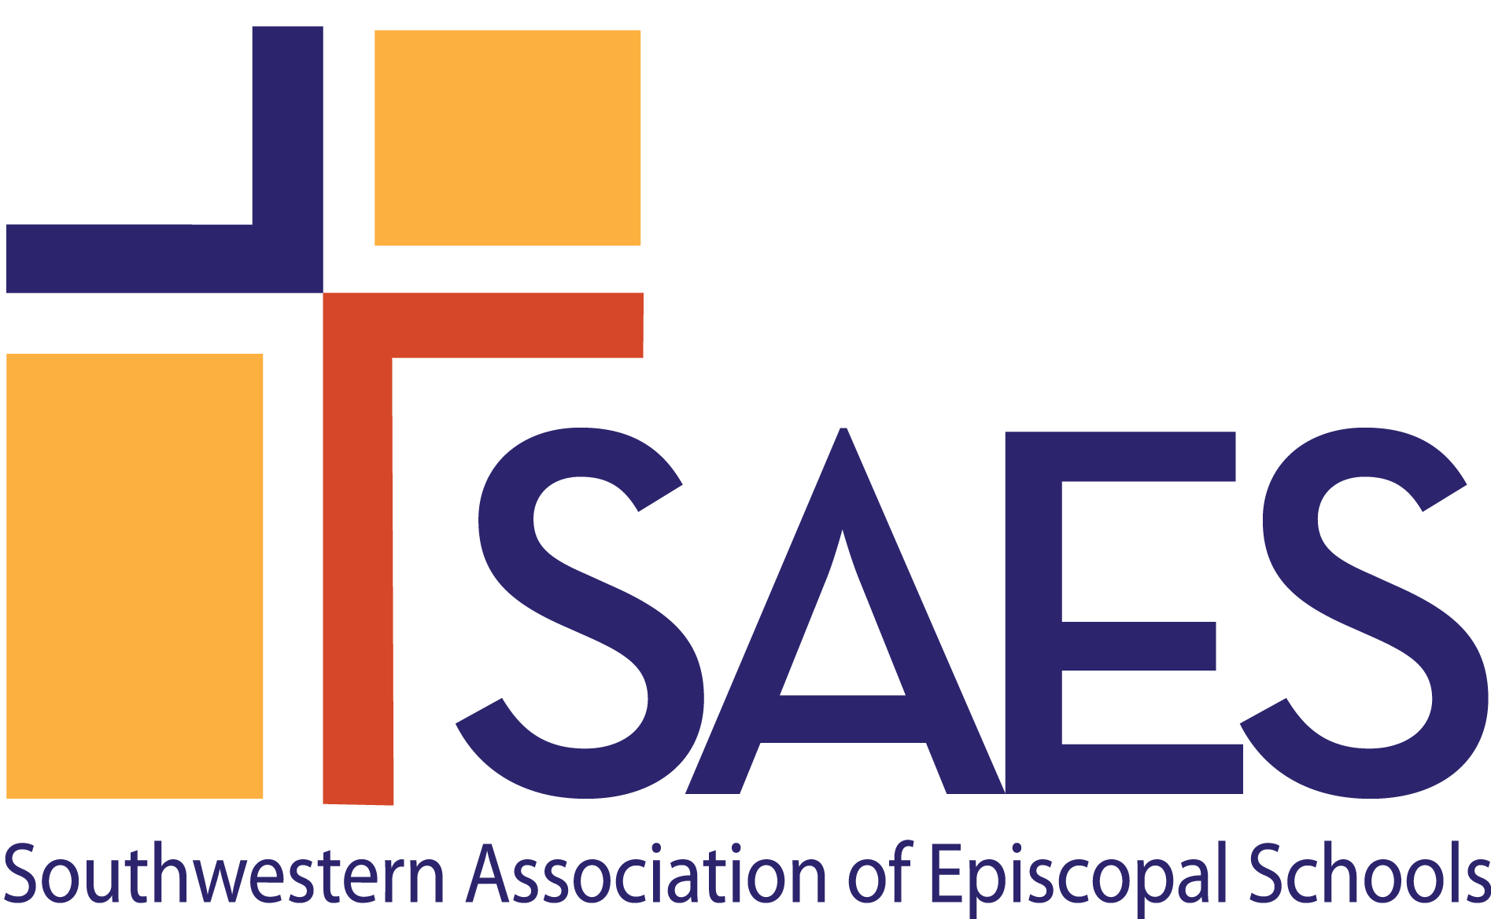

Episcopal Identity,
School Climate & Culture:

A Self-Study Section for
Dual Accreditation

The process for Episcopal schools to achieve and maintain dual accreditation with another accrediting association is a collaboration with that association’s requirements. Episcopal Identity, School Climate & Culture: A Self-Study Section for Dual Accreditation reflects the interest of SAES in each school’s efforts to meet the Standards of SAES and provide the highest quality school program. This section is to be completed in conjunction with the Self-Study of the other approved association and will focus on the Episcopal Identity of the school. In the spirit of openness and with a shared goal of school improvement, the Self-Study should be as complete and honest as possible, with a focus on not only the successes already achieved but also the challenges the school faces and future plans to address these.

SAES will collaborate with the other association and the school on logistics of the Self-Study and On-Site Visit and on creation of the Report of the On-Site Visiting Team; however, a determination of accreditation will be made independently by each association. Pending the award of accreditation by SAES, the two associations will coordinate the submission of interim reports.

INSTRUCTIONS FOR COMPLETING SELF-STUDY

- When approved to begin preparation for a dual accreditation, the head of school appoints a committee of the Self-Study to be focused on the SAES Episcopal Identity, School Climate & Culture section. The committee works in concert with the school’s Self-Study Steering Committee.

- Please send the names and contact information of the Steering Committee Chair and the Chair of the Episcopal Identity section to the SAES Director of Accreditation, jstark@swaes.org.

- In addition to the documents required in the other association’s Documents in Adherence to Standards, SAES requires schools seeking dual accreditation to submit specific documents that pertain to the school’s Episcopal identity and relationship with the sponsoring parish/diocese. those documents are listed in the chart below. There is no need to duplicate a document required by both associations.

- Append this report to the other association’s Self-Study as a separate section, and submit the combined Self-Study according to the lead association’s timeline and guidelines. Additionally, send a digital version of the entire Self-Study to jstark@swaes.org, and pblevins@swaes.org.

SAES Annual Report for 2021-2022

Contact the SAES office for an insertable version of the school’s SAES Annual Report. [Insert here]

B. EPISCOPAL IDENTITY, SCHOOL CLIMATE AND CULTURE

B.1 The Episcopal Identity of the school is expressed within its mission and governance structure, school organization, and operations.

- Explain the relationship between the school and the sponsoring parish/mission and diocese. [Insert School Response here.]

- How is the school’s Episcopal Identity reflected in the mission of the school? [Insert School Response here.]

- Describe that which captures the spirit of Episcopal education in the school’s program and culture. [Insert School Response here.]

- How has the school’s Episcopal Identity informed the work of the Board? [Insert School Response here.]

- What written policies are in place to clarify shared space issues and joint school-church financial obligations? [Insert School Response here.]

- In what ways does the Episcopal ethos of inclusion influence the admissions process? [Insert School Response here.]

- In what ways does the Episcopal ethos of inclusion influence the hiring and orientation of personnel? [Insert School Response here.]

- How does the Head of School act as the primary advocate for the school’s Episcopal Identity? [Insert School Response here.]

As modeled above, insert the school’s response after each question going forward.

B.2 Episcopal Identity is evident in the spiritual, intellectual, and socio-emotional development of all students.

- How does the school offer meaningful, age-appropriate worship experiences sensitive to the diversity of religious identity as represented by students and faculty?

- How does the school remain faithful to Episcopal liturgy, practices, and traditions?

- How is religious education incorporated into the instructional program?

- How does the school address students’ spiritual development?

B.3 The program reflects the Episcopal commitment to being a caring, inviting and welcoming community, which supports varied religious, cultural, and economic backgrounds, and family structures in the school community.

- Provide an example of how the school is caring, welcoming, and inviting.

- How does the school support varied religious, cultural, and economic backgrounds and family structures in the school community.

- In what ways does the pastoral care that is provided for the school community reflect the school’s Episcopal Identity?

B.4 The school provides opportunities for student participation in meaningful programs of service to others with respect for the dignity of every human being.

- In what ways does the school provide students with experiences to develop a social ethic that fosters mutual respect and concern for individual and community rights, equity, and justice?

- Describe any service projects or partnerships the school has developed to enhance students’ awareness of community and global responsibility.

B.5 The school interacts with the community in which it resides, including the parish (if applicable) and the diocese in which it is located.

- What community resources, human and otherwise, does the school use?

- Give examples of how the school shares its resources with the greater community?

- In what ways do the Head of School and the Rector/Bishop’s Representative maintain an open and collaborative relationship in support of school operations?

SCHOOL RESPONSE – OBSERVATIONS & CONCLUSIONS

- As you reflect upon the school’s Episcopal Identity, school climate and culture, what are the school’s greatest strengths in this area?

- What are the areas that need improvement? How does the school plan to address them?

List the names and titles of each person who contributed to this section.
SAES Documents in Adherence to Standards for Episcopal Identity, School Climate & Culture

These documents should be placed in a separate section titled Episcopal Identity, School Climate & Culture within the Documents in Adherence to Standards required by the other association and labeled accordingly. There is no need to duplicate a document required by both associations.

EPISCOPAL IDENTITY, SCHOOL CULTURE AND CLIMATE
1 | Chapel service schedule and order of service with age group(s)/ school divisions indicated
2 | Programs from graduations and other ceremonial events
3 | Evidence of statements of Episcopal Identity in school publications
4 | Diocesan canons that pertain to the school
5 | Religion education curriculum
6 | Evidence that anyone working with students on a regular basis, within or outside the school day/year, has been certified/re-certified in Safeguarding
7 | School/church shared use agreement (if applicable), together with description of how costs are allocated
8 | If the school is separately incorporated, evidence of 501(c)(3) status. If not, provide evidence that the school is by charter affiliated with a legally constituted not-for-profit church.

