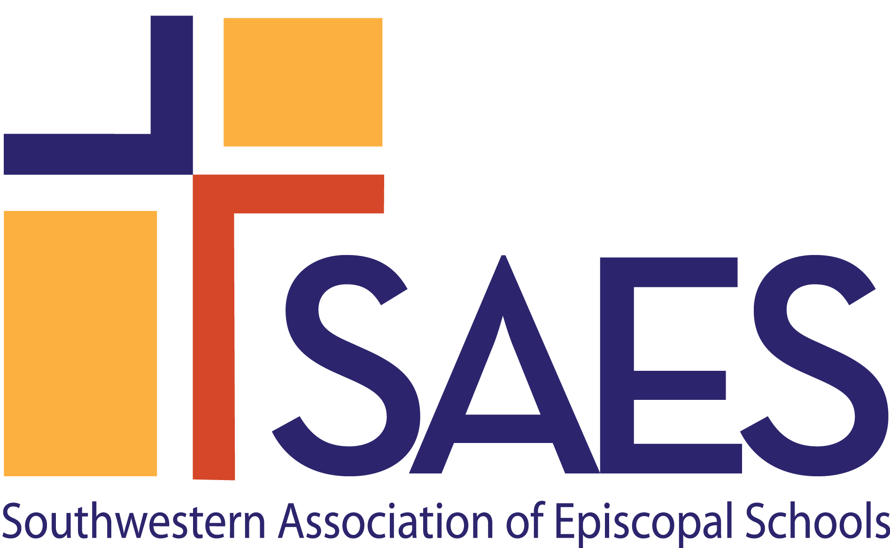

Episcopal Identity, School Climate & Culture:
A Self-Study Section for
Dual Accreditation
v.6.18

Southwestern Association of Episcopal Schools
1420 4th Ave.
Suite 29
Canyon, TX 79015-3748
Tel: 806-655-2400
Email: www.swaes.org
The process for Episcopal schools to achieve and maintain dual accreditation with another accrediting association is a collaboration with that association’s requirements. Episcopal Identity, School Climate & Culture: A Self-Study Section for Dual Accreditation reflects the interest of SAES in each school’s efforts to meet the Standards of SAES and provide the highest quality school program. This section is to be completed in conjunction with the Self-Study of the other approved association and will focus on the Episcopal Identity of the school. In the spirit of openness and with a shared goal of school improvement, the Self-Study should be as complete and honest as possible, with a focus on not only the successes already achieved but also the challenges the school faces and future plans to address these.

SAES will collaborate with the other association and the school on logistics of the Self-Study and On-Site Visit and on creation of the Report of the Visiting Team; however, a determination of accreditation will be made independently by each association. Pending the award of accreditation by SAES, the two associations will coordinate the submission of interim reports.

Guidelines

- When approved to begin preparation for a dual accreditation, the head of school should appoint a committee of the Self-Study to be focused on the SAES Episcopal Identity, School Climate & Culture section. The committee should include representatives from many constituencies of the school and should work in concert with the school’s Self-Study Steering Committee.

- The head of school should send the names and contact information of the Steering Committee Chair (a.k.a. Self-Study Coordinator) and the Chair of the Episcopal Identity section to the SAES Director of Accreditation Services, skirkpatrick@swaes.org.

- The report for this section of the self-study must contain the items shown in the template below.

- In addition to the documents required in the other association’s Documents in Adherence to Standards, SAES requires schools seeking dual accreditation to submit specific documents that pertain to the school’s Episcopal identity and relationship with the sponsoring parish/diocese. There is no need to duplicate a document required by both associations. Just indicate the alternate location.

- Insert this report to the other association’s Self-Study as a separate section. The combined Self-Study should be submitted according to the lead association’s timeline and guidelines. Additionally, the SAES Director of Accreditation Services, skirkpatrick@swaes.org, the SAES Office Manager, pblevins@swaes.org, and the Associate Director of Accreditation Services, sschotz@swaes.org, should receive a digital version of the entire Self-Study.

[Note: Should the school wish to use this template for the SAES Self-Study Report, please delete the instructions shown in red.]

COVER PAGE FOR SAES/ISAS SELF-STUDY
School Name:
School Address:
City, County, State, Zip:
School Website:
School Phone #: Date:

ACKNOWLEDGEMENT OF THE SAES MEMBERSHIP and ACCREDITATION REQUIREMENTS
- The school shall retain its membership in the Association.
- The school shall be affiliated with The Episcopal Church (TEC) that is part of the Anglican Communion. The school shall be a parish day school, a school owned or administered by a diocese or religious order or group of parishes, or an independent school which espouses the faith and worship of the Episcopal Church in America as set forth in the Book of Common Prayer, and operates with the knowledge and consent of the Bishop of the diocese.
- The school shall be a non-profit institution 501(c)(3) or part of a non-profit institution.
- Implement employment and admissions policies, in keeping with its mission and culture, as well as its practices reflect the Episcopal tradition of respect for the dignity of every human being. The school promotes an equitable, just, and inclusive community, and its policies and practices shall reflect accordingly. Unlawful discrimination has no place in SAES schools. A school is expected to abide by a non-discrimination policy that complies with IRS regulations.
- The school shall be in, at least, its third year of operation.
- The school shall meet its SAES financial (membership & accreditation dues and fees).
- The school shall demonstrate commitment to on-going school improvement and fulfill the requirements of the SAES accreditation process.
- The school shall complete the SAES Annual Report and participate in Data Analysis for School Leadership (DASL) as directed by SAES.

Completion of this section indicates that this Self-Study has been reviewed and approved by the Head of School and Board President
____________________________________ ____________________________________
Head of School (printed name) Head of School (signature)

______________________
Date

____________________________________ ____________________________________
President of Board of Trustees (printed name) President of Board of Trustees (signature)

______________________
Date

Head of School E-mail: ___________________________________
Board President E-mail: ___________________________________
Rector (if applicable) Name and E-Mail: ___________________, ____________________
Steering Committee Chair (Self-Study Coordinator):
Name:________________________________
Email: ________________________________
Chair for Episcopal Identity, School Climate & Culture Committee Section:
Name:________________________________
Email: ________________________________
Episcopal Identity, School Climate & Culture Committee Members:
SAES Annual Report for 20___ - 20___
(Insert the school’s current year SAES Annual Report. Contact the SAES office for an insertable version of the report.)
Please include the SAES Standards, SCHOOL RESPONSE questions and responses. At the end of this section, please include the names and titles of people who worked on this section, indicating the committee chair.

B. EPISCOPAL IDENTITY, SCHOOL CLIMATE AND CULTURE

B.1. The Episcopal Identity of the school shall be expressed within its mission and governance structure, school organization, and operations.

SCHOOL RESPONSE
- Explain the relationship between the school and the sponsoring parish/mission and diocese.
- How is the school’s Episcopal Identity reflected in the mission of the school?
- Describe that which captures the spirit of Episcopal education in the school’s program and culture.
- How has the school’s Episcopal Identity informed the work of the Board?
- What written policies are in place to clarify shared space issues and joint school-church financial obligations?
- In what ways does the Episcopal ethos of inclusion influence the admissions process?
- In what ways does the Episcopal ethos on inclusion influence the hiring and orientation of personnel?
- How does the Head of School act as the primary advocate for the school’s Episcopal Identity?

B.2 Episcopal Identity shall be evident in the spiritual, intellectual, and socio-emotional development of all students.

SCHOOL RESPONSE
- How does the school offer meaningful, age-appropriate worship experiences sensitive to the diversity of religious identity as represented by students and faculty? How does the school remain faithful to Episcopal liturgy, practices, and traditions?
- How is religious education incorporated into the instructional program?
- How does the school address students’ spiritual development?

B.3 The program shall reflect the Episcopal commitment to being a caring, inviting and welcoming community, which supports varied religious, cultural, and economic backgrounds and family structures in the school community.

SCHOOL RESPONSE
- Provide an example of how the school is caring, welcoming, and inviting.
- How does the school support varied religious, cultural, and economic backgrounds and family structures in the school community.
- In what ways does the pastoral care that is provided for the school community reflect the school’s Episcopal Identity?

B.4. The school shall provide opportunities for student participation in meaningful programs of service to others with respect for the dignity of every human being.

SCHOOL RESPONSE
- In what ways does the school provide students with experiences to develop a social ethic that fosters mutual respect and concern for individual and community rights, equity, and justice?
- Describe any service projects or partnerships the school has developed to enhance students’ awareness of community and global responsibility.

B.5. The school shall interact with the community in which it resides, including the parish (if applicable) and the diocese in which it is located.

SCHOOL RESPONSE
- What community resources, human and otherwise, does the school use?
- Give examples of how the school shares its resources with the greater community?

SCHOOL RESPONSE – OBSERVATIONS & CONCLUSIONS
- As you reflect upon the school’s Episcopal Identity, school climate and culture, what are the school’s greatest strengths in this area?
- What are the areas that need improvement? How does the school plan to address them?

SAES Documents in Adherence to Standards for Episcopal Identity, School Climate & Culture

These documents should be placed in a separate section titled Episcopal Identity, School Climate & Culture Documents in Adherence to Standards with the group of documents required by the other association and labeled accordingly. There is no need to duplicate a document required by both associations. Just indicate the alternate location. The documents will be reviewed by the On-Site Visiting Team at the time of the On-Site Visit.
B. Episcopal Identity, School Climate & Culture | 1 | Chapel service schedule and order of service with age group(s)/school division(s) indicated
 | 2 | Programs from graduations and other ceremonial events
 | 3 | Evidence of statements of Episcopal Identity in school publications
 | 4 | Diocesan canons that pertain to the school
 | 5 | Religion education curriculum.
 | 6 | Evidence that the school has a process for conducting initial background and for re-checking as required by state licensing (if applicable) and diocesan requirements. Checks have been made on all employees and regular volunteers, including third party providers and others working in programs that operate outside of the school day/year (such as before and after school care, weekend and summer programs. Include evidence that anyone working with students on a regular basis, within or outside the school day/year, has been certified/re-certified in Safeguarding God’s Children/People.
 | 7 | School/church shared use agreement (if applicable), together with description of how costs are allocated between church and school.
 | 8 | If the school is separately incorporated, evidence of 501(c)(3) status. If the school is not separately incorporated, provide evidence that the school is by charter affiliated with a legally constituted not-for-profit church.
 | 9 | By-laws
 | 10 | Parish day schools: Evidence that the school’s accounting is not commingled with church accounting, and that the school’s finances are overseen by the school’s Board of Trustees, which has fiduciary responsibility

